190905104
PCAP

Sample

#include "mpi.h"
#include <stdio.h>

int main(int argc, char* argv[]){
int rank, size;

MPI_Init(&argc, &argv);
MPI_Comm_rank(MPI_COMM_WORLD, &rank);
MPI_Comm_size(MPI_COMM_WORLD, &size);
printf("Rank: %d\tSize: %d\n", rank, size);
MPI_Finalize();
return 0;
}

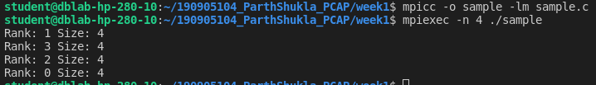

1)

#include<mpi.h>
#include<stdio.h>
#include<math.h>
int main(int argc,char* argv[]){

int rank,size;
MPI_Init(&argc,&argv);
MPI_Comm_size(MPI_COMM_WORLD, &size);
MPI_Comm_rank(MPI_COMM_WORLD,&rank);

int x=5;

int result=pow(x,rank);
printf("pow(x,rank) for process %d is %d \n",rank,result);

MPI_Finalize();
return 0;
}

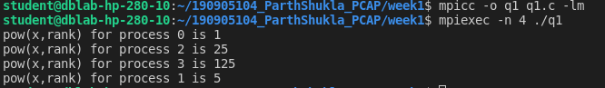

2)

#include<mpi.h>
#include<stdio.h>

int main(int argc,char* argv[])
{
int rank,size;
MPI_Init(&argc,&argv);
MPI_Comm_size(MPI_COMM_WORLD, &size);
MPI_Comm_rank(MPI_COMM_WORLD,&rank);

if(rank%2==0){
printf("in process %d : Hello \n",rank);
}
else{
printf("in process %d : World \n",rank);
}
MPI_Finalize();
return 0;
}

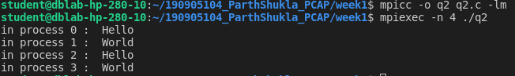

3)

#include<mpi.h>
#include<stdio.h>

int main(int argc,char* argv[])
{
int rank,size;
int num1=30;
int num2=9;
MPI_Init(&argc,&argv);
MPI_Comm_size(MPI_COMM_WORLD, &size);
MPI_Comm_rank(MPI_COMM_WORLD,&rank);

if(rank==0){
int sum=num1+num2;
printf("Process %d: SUM of %d and %d is %d \n",rank,num1,num2,sum);
}
else if(rank==1){
int diff=num1-num2;
printf("Process %d: DIFFERENCE of %d and %d is %d \n",rank,num1,num2,diff);
}
else if(rank==2){
int mul=num1*num2;
printf("Process %d: PRODUCT of %d and %d is %d \n",rank,num1,num2,mul);
}
else if(rank==3){
float quot=num1/num2;
printf("Process %d: QUOTIENT of %d and %d is %f \n",rank,num1,num2,quot);
}
MPI_Finalize();
return 0;
}

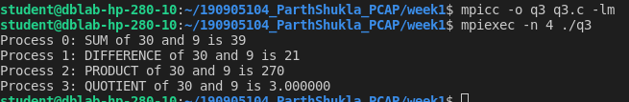

4)

#include<mpi.h>
#include<stdio.h>
#include<ctype.h>

char toggle(char c){
if(c >= 'a' && c <= 'z'){
return toupper(c);
}
else{
return tolower(c);
}
return c;
}
int main(int argc,char* argv[])
{
int rank,size;
char s[5]="HeLLo";
MPI_Init(&argc,&argv);
MPI_Comm_size(MPI_COMM_WORLD, &size);
MPI_Comm_rank(MPI_COMM_WORLD,&rank);

s[rank] = toggle(s[rank]);
printf("In process %d..string after toggling is %s \n",rank,s);

MPI_Finalize();
return 0;

}

